**Trabalho 1 – Pedro Company Beck - 324055**

1. Descrição do trabalho

Este trabalho visa implementar o processador hipotético Neander em um circuito VHDL, além disso são adicionadas as instruções SUB e XOR para o conjunto de instruções do processador e foram escritos três programas para testar a implementação do processador. Todos os arqiuvos fonte e as imagens incluídas nesse relatório estão em anexo.

1. VHDL completo do Neander

----------------------------------------------------------------------------------

-- Company:

-- Engineer: Pedro Company Beck

--

-- Create Date: 00:46:28 07/20/2023

-- Design Name:

-- Module Name: neander - Behavioral

-- Project Name:

-- Target Devices:

-- Tool versions:

-- Description:

--

-- Dependencies:

--

-- Revision:

-- Revision 0.01 - File Created

-- Additional Comments:

--

----------------------------------------------------------------------------------

library IEEE;

use IEEE.STD_LOGIC_1164.ALL;

use IEEE.NUMERIC_STD.ALL;

-- Uncomment the following library declaration if instantiating

-- any Xilinx primitives in this code.

--library UNISIM;

--use UNISIM.VComponents.all;

entity neander is

Port (

rst: in STD_LOGIC;

clk: in STD_LOGIC;

outHalt: out STD_LOGIC;

outPC: out STD_LOGIC_VECTOR(7 downto 0);

outAC: out STD_LOGIC_VECTOR(7 downto 0);

outRI: out STD_LOGIC_VECTOR(3 downto 0)

);

end neander;

architecture Behavioral of neander is

COMPONENT mem1

PORT (

clka : IN STD_LOGIC;

wea : IN STD_LOGIC_VECTOR(0 DOWNTO 0);

addra : IN STD_LOGIC_VECTOR(7 DOWNTO 0);

dina : IN STD_LOGIC_VECTOR(7 DOWNTO 0);

douta : OUT STD_LOGIC_VECTOR(7 DOWNTO 0)

);

END COMPONENT;

type states is (t0, t1, t2, t3, t4, t5, t6, t7);

signal state: states;

signal incPC, cargaPC: STD_LOGIC;

signal saidaPC: STD_LOGIC_VECTOR(7 downto 0);

signal s1MPX: STD_LOGIC;

signal saidaMPX: STD_LOGIC_VECTOR(7 downto 0);

signal cargaREM: STD_LOGIC;

signal saidaREM: STD_LOGIC_VECTOR(7 downto 0);

signal entradaMEM: STD_LOGIC_VECTOR(7 downto 0);

signal readMEM: STD_LOGIC;

signal writeMEM: STD_LOGIC_VECTOR(0 downto 0);

signal saidaMEM: STD_LOGIC_VECTOR(7 downto 0);

signal cargaRI: STD_LOGIC;

signal saidaRI: STD_LOGIC_VECTOR(3 downto 0);

signal cargaAC: STD_LOGIC;

signal saidaAC: STD_LOGIC_VECTOR(7 downto 0);

signal cargaNZ: STD_LOGIC;

signal saidaNZ: STD_LOGIC_VECTOR(1 downto 0);

signal selALU: STD_LOGIC_VECTOR(2 downto 0);

signal saidaALU: STD_LOGIC_VECTOR(7 downto 0);

signal nzALU: STD_LOGIC_VECTOR(1 downto 0);

begin

memoria : mem1

PORT MAP (

clka => clk,

wea => writeMEM,

addra => saidaREM,

dina => entradaMEM,

douta => saidaMEM

);

outPC <= saidaPC;

outAC <= saidaAC;

outRI <= saidaRI;

process(clk, rst) -- state machine

begin

if rst = '1' then

state <= t0;

elsif clk'event and clk = '1' then

case state is

when t0 =>

state <= t1;

when t1 =>

state <= t2;

when t2 =>

state <= t3;

when t3 =>

if (saidaRI = "0000") -- NOP

or (saidaRI = "0110") -- NOT

or (saidaRI = "1001" and saidaNZ(1) = '0') -- JN, N=0

or (saidaRI = "1010" and saidaNZ(0) = '0') -- JZ, Z=0

then

state <= t0;

elsif (saidaRI = "0001") -- STA

or (saidaRI = "0010") -- LDA

or (saidaRI = "0011") -- ADD

or (saidaRI = "0100") -- OR

or (saidaRI = "0101") -- AND

or (saidaRI = "1000") -- JMP

or (saidaRI = "1001" and saidaNZ(1) = '1') -- JN, N=1

or (saidaRI = "1010" and saidaNZ(0) = '1') -- JZ, Z=1

or (saidaRI = "1011") -- XOR

or (saidaRI = "1100") -- SUB

then

state <= t4;

end if;

when t4 =>

state <= t5;

when t5 =>

if (saidaRI = "0001") -- STA

or (saidaRI = "0010") -- LDA

or (saidaRI = "0011") -- ADD

or (saidaRI = "0100") -- OR

or (saidaRI = "0101") -- AND

or (saidaRI = "1011") -- XOR

or (saidaRI = "1100") -- SUB

then

state <= t6;

elsif (saidaRI = "1000") -- JMP

or (saidaRI = "1001" and saidaNZ(1) = '1') -- JN, N=1

or (saidaRI = "1010" and saidaNZ(0) = '1') -- JZ, Z=1

then

state <= t0;

end if;

when t6 =>

state <= t7;

when t7 =>

state <= t0;

when others =>

state <= state;

end case;

end if;

end process;

process(state, saidaNZ, saidaRI, saidaAC) -- fsm

begin

incPC <= '0';

s1MPX <= '0';

readMEM <= '0';

writeMEM <= "0";

cargaPC <= '0';

cargaREM <= '0';

cargaRI <= '0';

cargaAC <= '0';

cargaNZ <= '0';

selALU <= "111";

entradaMEM <= "00000000";

outHalt <= '0';

case state is

when t0 =>

s1MPX <= '0';

cargaREM <= '1';

when t1 =>

readMEM <= '1';

incPC <= '1';

when t2 =>

cargaRI <= '1';

when t3 =>

if (saidaRI = "0001") -- STA

or (saidaRI = "0010") -- LDA

or (saidaRI = "0011") -- ADD

or (saidaRI = "0100") -- OR

or (saidaRI = "0101") -- AND

or (saidaRI = "1000") -- JMP

or (saidaRI = "1001" and saidaNZ(1) = '1') -- JN, N=1

or (saidaRI = "1010" and saidaNZ(0) = '1') -- JZ, Z=1

or (saidaRI = "1011") -- XOR

or (saidaRI = "1100") -- SUB

then

s1MPX <= '0';

cargaREM <= '1';

elsif saidaRI = "0110" then -- NOT

selALU <= "011"; -- not X

cargaAC <= '1';

cargaNZ <= '1';

elsif (saidaRI = "1001" and saidaNZ(1) = '0') -- JN, N=0

or (saidaRI = "1010" and saidaNZ(0) = '0') -- JZ, Z=0

then

incPC <= '1';

elsif saidaRI = "1111" then -- HLT

outHalt <= '1';

else

end if;

when t4 =>

if (saidaRI = "0001") -- STA

or (saidaRI = "0010") -- LDA

or (saidaRI = "0011") -- ADD

or (saidaRI = "0100") -- OR

or (saidaRI = "0101") -- AND

or (saidaRI = "1011") -- XOR

or (saidaRI = "1100") -- SUB

then

readMEM <= '1';

incPC <= '1';

elsif (saidaRI = "1000") -- JMP

or (saidaRI = "1001" and saidaNZ(1) = '1') -- JN, N=1

or (saidaRI = "1010" and saidaNZ(0) = '1') -- JZ, Z=1

then

readMEM <= '1';

else

end if;

when t5 =>

if (saidaRI = "0001") -- STA

or (saidaRI = "0010") -- LDA

or (saidaRI = "0011") -- ADD

or (saidaRI = "0100") -- OR

or (saidaRI = "0101") -- AND

or (saidaRI = "1011") -- XOR

or (saidaRI = "1100") -- SUB

then

s1MPX <= '1';

cargaREM <= '1';

elsif (saidaRI = "1000") -- JMP

or (saidaRI = "1001" and saidaNZ(1) = '1') -- JN, N=1

or (saidaRI = "1010" and saidaNZ(0) = '1') -- JZ, Z=1

then

cargaPC <= '1';

else

end if;

when t6 =>

if (saidaRI = "0001") then -- STA

-- cargaRDM <= 1

else -- LDA, ADD, OR, AND, XOR, SUB

readMEM <= '1';

end if;

when t7 =>

if (saidaRI = "0001") then -- STA

writeMEM <= "1";

entradaMEM <= saidaAC;

elsif (saidaRI = "0010") then -- LDA

selALU <= "100"; -- Y

cargaAC <= '1';

cargaNZ <= '1';

elsif (saidaRI = "0011") then -- ADD

selALU <= "000";

cargaAC <= '1';

cargaNZ <= '1';

elsif (saidaRI = "0100") then -- OR

selALU <= "010"; -- X or Y

cargaAC <= '1';

cargaNZ <= '1';

elsif (saidaRI = "0101") then -- AND

selALU <= "001"; -- X and Y

cargaAC <= '1';

cargaNZ <= '1';

elsif (saidaRI = "1011") then -- XOR

selALU <= "110"; -- X xor Y

cargaAC <= '1';

cargaNZ <= '1';

elsif (saidaRI = "1100") then -- SUB

selALU <= "101"; -- X - Y

cargaAC <= '1';

cargaNZ <= '1';

else

end if;

when others =>

end case;

end process;

process(clk, rst) -- PC

begin

if rst = '1' then

saidaPC <= "00000000";

elsif clk'event and clk = '1' then

if cargaPC = '1' then

saidaPC <= saidaMEM;

else

if incPC = '1' then

saidaPC <= STD_LOGIC_VECTOR(1 + unsigned(saidaPC));

else

saidaPC <= saidaPC;

end if;

end if;

else

end if;

end process;

process(clk) -- AC

begin

if clk'event and clk = '1' then

if cargaAC = '1' then

saidaAC <= saidaALU;

else

saidaAC <= saidaAC;

end if;

end if;

end process;

process(s1MPX, saidaPC, saidaMEM) -- MPX

begin

if s1MPX = '0' then

saidaMPX <= saidaPC;

else

saidaMPX <= saidaMEM;

end if;

end process;

process(clk) -- REM

begin

if clk'event and clk = '1' then

if cargaREM = '1' then

saidaREM <= saidaMPX;

else

saidaREM <= saidaREM;

end if;

else

end if;

end process;

process(selALU, saidaAC, saidaMEM, saidaALU) -- ALU

begin

case selALU is

when "000" => -- X + Y

saidaALU <= STD_LOGIC_VECTOR(unsigned(saidaAC) + unsigned(saidaMEM));

when "001" => -- X and Y

saidaALU <= saidaAC and saidaMEM;

when "010" => -- X or Y

saidaALU <= saidaAC or saidaMEM;

when "011" => -- not X

saidaALU <= not saidaAC;

when "100" => -- Y

saidaALU <= saidaMEM;

when "101" => -- X - Y

saidaALU <= STD_LOGIC_VECTOR(unsigned(saidaAC) - unsigned(saidaMEM));

when "110" => -- X xor Y

saidaALU <= saidaAC xor saidaMEM;

when others => -- 111

saidaALU <= saidaAC;

end case;

end process;

process(saidaALU) -- saidaNZ

begin

if saidaALU = "00000000" then

nzALU(0) <= '1';

else

nzALU(0) <= '0';

end if;

if saidaALU(7) = '1' then

nzALU(1) <= '1';

else

nzALU(1) <= '0';

end if;

end process;

process(clk) -- NZ

begin

if clk'event and clk = '1' then

if cargaNZ = '1' then

saidaNZ <= nzALU;

else

saidaNZ <= saidaNZ;

end if;

else

end if;

end process;

process(clk) -- RI

begin

if clk'event and clk = '1' then

if cargaRI = '1' then

saidaRI(3) <= saidaMEM(7);

saidaRI(2) <= saidaMEM(6);

saidaRI(1) <= saidaMEM(5);

saidaRI(0) <= saidaMEM(4); -- rest = don't care

else

saidaRI <= saidaRI;

end if;

else

end if;

end process;

end Behavioral;

1. Testbench VHDL completo

--------------------------------------------------------------------------------

-- Company:

-- Engineer: Pedro Company Beck

--

-- Create Date: 10:09:39 07/25/2023

-- Design Name:

-- Project Name: placa1

-- Target Device:

-- Tool versions:

-- Description:

--

-- VHDL Test Bench Created by ISE for module: neander

--

-- Dependencies:

--

-- Revision:

-- Revision 0.01 - File Created

-- Additional Comments:

--

-- Notes:

-- This testbench has been automatically generated using types std_logic and

-- std_logic_vector for the ports of the unit under test. Xilinx recommends

-- that these types always be used for the top-level I/O of a design in order

-- to guarantee that the testbench will bind correctly to the post-implementation

-- simulation model.

--------------------------------------------------------------------------------

LIBRARY ieee;

USE ieee.std_logic_1164.ALL;

-- Uncomment the following library declaration if using

-- arithmetic functions with Signed or Unsigned values

--USE ieee.numeric_std.ALL;

ENTITY testbench1 IS

END testbench1;

ARCHITECTURE behavior OF testbench1 IS

-- Component Declaration for the Unit Under Test (UUT)

COMPONENT neander

PORT(

rst : IN std_logic;

clk : IN std_logic;

outHalt : OUT std_logic;

outPC : OUT STD_LOGIC_VECTOR(7 downto 0);

outAC : OUT STD_LOGIC_VECTOR(7 downto 0);

outRI : OUT STD_LOGIC_VECTOR(3 downto 0)

);

END COMPONENT;

--Inputs

signal rst : std_logic := '0';

signal clk : std_logic := '0';

--Outputs

signal outHalt : std_logic;

signal outPC: STD_LOGIC_VECTOR(7 downto 0);

signal outAC: STD_LOGIC_VECTOR(7 downto 0);

signal outRI: STD_LOGIC_VECTOR(3 downto 0);

-- Clock period definitions

constant clk_period : time := 10 ns;

BEGIN

-- Instantiate the Unit Under Test (UUT)

duv: neander PORT MAP (

rst => rst,

clk => clk,

outHalt => outHalt,

outPC => outPC,

outAC => outAC,

outRI => outRI

);

-- Clock process definitions

process

begin

clk <= '0';

wait for clk_period/2;

clk <= '1';

wait for clk_period/2;

end process;

-- -- Stimulus process

process

begin

-- hold reset state for 100 ns.

wait for 100 ns;

-- insert stimulus here

rst <= '1';

wait for clk_period;

rst <= '0';

wait for 1000000ns;

end process;

END;

1. Explicação e descrição das aplicações em Assembly

PROGRAMA 1:

Esse programa se automodifica para incrementar os próprios endereços de escrita e leitura e executa 9 vezes as três primeiras instruções para somar os 9 valores de uma matriz 3x3 e guardar no espaço de memória reservado para o output.

Assembly do Neander:

0: NOP

1-2: LDA 128

3-4: ADD 137

5-6: STA 146

-- self-modifying code

7-8: LDA 2

9-10: ADD 127

11-12: STA 2

13-14: LDA 4

15-16: ADD 127

17-18: STA 4

19-20: LDA 6

21-22: ADD 127

23-24: STA 6

-- inc counter

25-26: LDA 126

27-28: ADD 127

-- jz to hlt

29-30: JZ 35

-- else

31-32: STA 126

33-34: JMP 1

35: HLT

-- data

126: 247

127: 1

128 - 136: matrix A

137 - 145: matrix B

146 - 154: output

PROGRAMA 2:

Esse programa utiliza o primeiro operando como contador e soma o segundo operando sucessivamente na output.

O programa utiliza a instrução SUB implementada para subtrair 1 do valor do contador (endereço do primeiro operando) até o mesmo chegar a 0.

Na execução, foram utilizados os valores A = 3 e B = 5, então a soma sucessiva é realizada 3 vezes.

Assembly do Neander:

0: NOP

1-2: LDA 128

3-4: JZ 17

5-6: SUB 127 -- sub = 11000000 = C0 = 192

7-8: STA 128

9-10: LDA 130

11-12: ADD 129

13-14: STA 130

15-16: JMP 1

17: HLT

-- data

127: 1

128: A

129: B

130: out

PROGRAMA 3:

Esse programa utiliza a instrução XOR implementada para realizar o swap de dois valores em memória sem utilizar nenhum endereço de memória temporária.

Assembly do Neander:

-- swap two values in place

0: NOP

1-2: LDA 128

3-4: XOR 129 -- XOR = 1011 0000 = B0 = 176

5-6: STA 128

7-8: LDA 129

9-10: XOR 128

11-12: STA 129

13-14: LDA 128

15-16: XOR 129

17-18: STA 128

19: HLT

-- data

128: A

129: B

1. Simulações sem e com atraso com detalhes e flechas mostrando inicio meio e final do programa e resultados

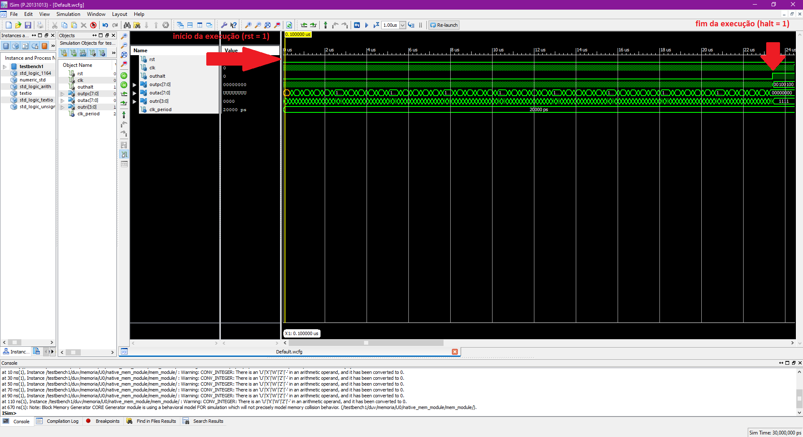

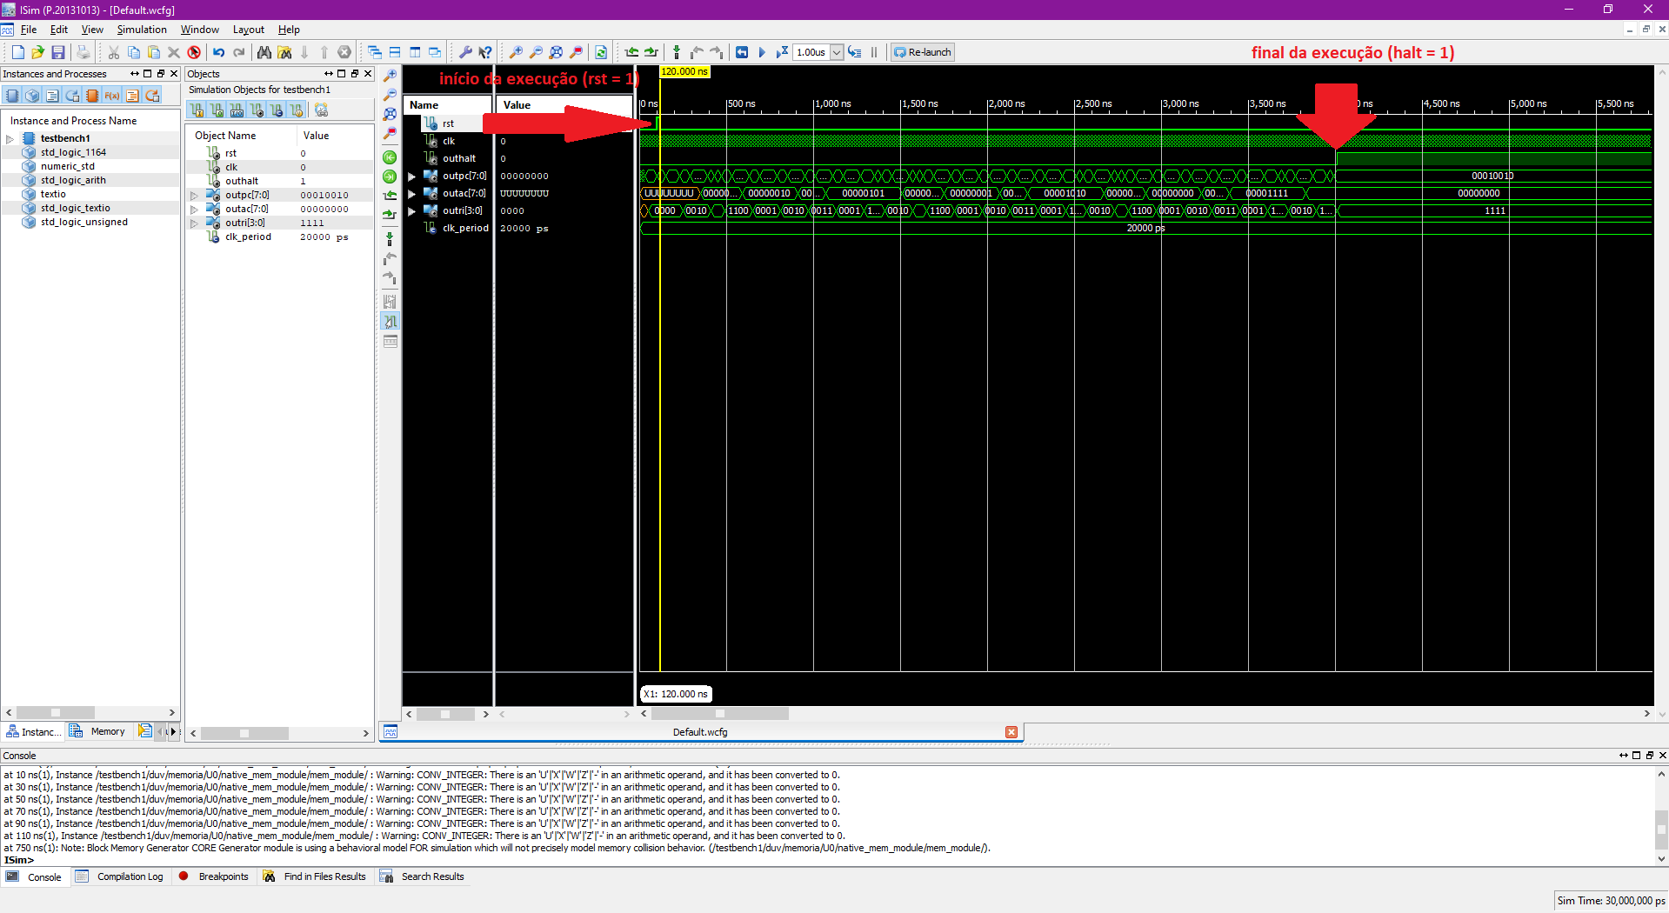

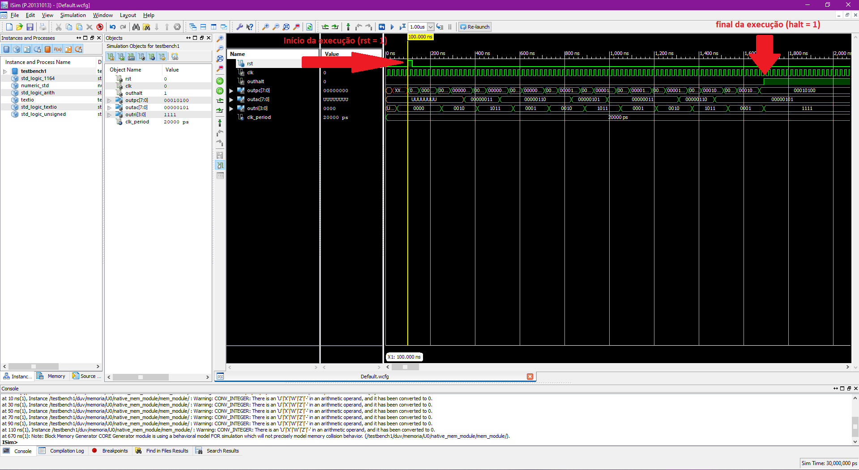

1. Dados de área, tempo de execução em ciclos de relógio e tempo em segundos deve ser apresentado dado um determinado clock usado.

|  |  |  |  |
| --- | --- | --- | --- |
| Programa | Numero de Instruções Executadas | Tempo de execução em # de ciclos de relógio (c.c.) | Tempo de execução em Segundos  (Neander operando a 50 MHz) (T = 20ns) |
| Soma de matrizes | 153 | 1165 | 23300ns = 0.0000233s |
| Multiplicação por somas sucessivas | 28 | 195 | 3900ns = 0.0000039s |
| Programa com XOR | 11 | 79 | 1580ns = 0.00000158s |

**Dados de Area do Neander**

FPGA device: xc3s100e-5vq100

Numero de 4-LUTs ou 6-LUTs (conforme o FPGA): used = 135 / available = 1920

Numero de ffps: used = 39 / available = 1920

Numero de BRAM: used = 1 / available = 4

Numero de DSP:

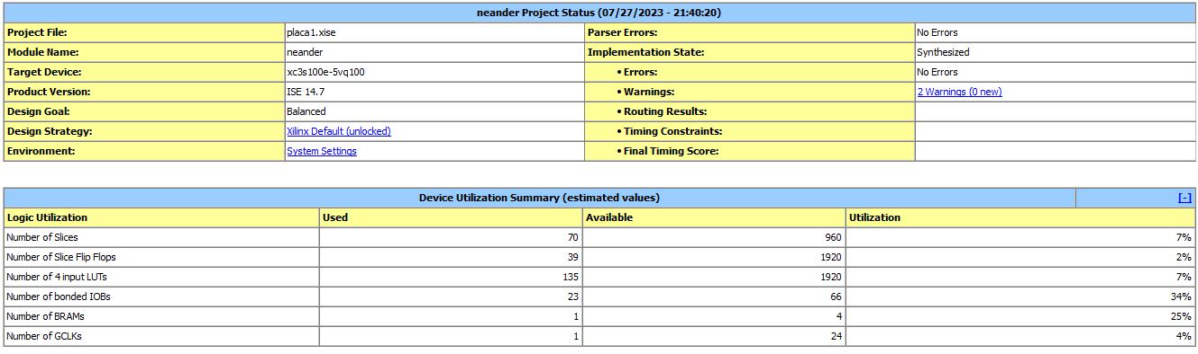

1. **(1 ponto extra)** Se o Neander for prototipado na placa de prototipação, mostrar vídeos do funcionamento mostrando dados da memória do Neander (debugger com memória BRAM dual port, chaves para controlar os endereços de memória e display 7seg para mostrar os resultados).